Create External Non-Container DB with ORM Stack

Contents

1. Introduction 1
2. Workflow diagram to deploy the stack 1
3. Create stack for External Non-Container DB 2
4. Plan the Job 6

Introduction
It is possible to manage and monitor Oracle Databases that are located outside of Oracle Cloud Infrastructure (OCI) using external databases. External database allows us to use cloud-based tools such as Database Management with your external databases. External database can be used with both single-instance Oracle Databases and Oracle RAC instances.

To manage an external database, you create an OCI resource known as a "handle" that represents the external database within your tenancy. After creating a handle for your database, you create a second resource called a database connection. The connection stores the information required for your OCI tenancy to connect to the external database. After creating the connection resource and connecting the OCI handle to your external database instance, you can enable the Database Management service to monitor the health and performance of your database.

Workflow diagram to deploy the stack

Below diagram shows how the Terraform Artifact are applied in the OCI. While creating a ORM stack, using terraform deliverables Init, Plan and Apply is the flow to provision the resource in the OCI. We can have the deliverables in any of below.
- GitLab/GitHub Repo
- Bitbucket
- Can be in folder/.zip in the local disk
- Object Storage Bucket
- Can be in compartment
- Oracle provided Template


Create stack for External Non-Container DB

Go to OCI Console Developer Services Resource Manager Stacks select the compartment Create Stack

My Configuration Folder Browse Select the “External Non-Container DB” folder that contains the artifacts Upload

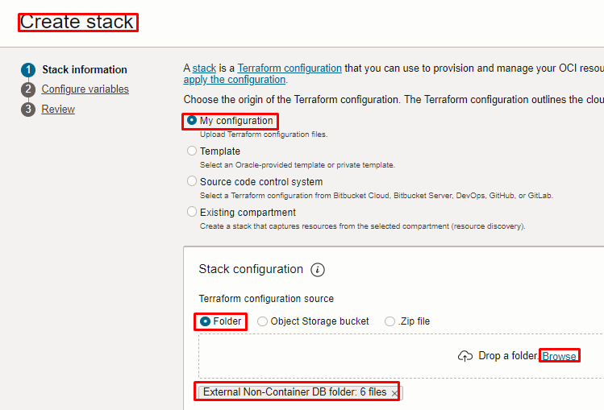
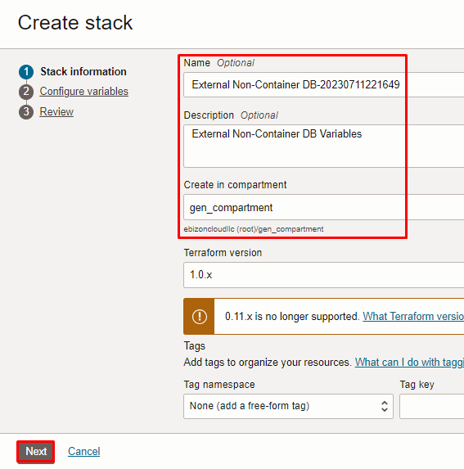

Click “NEXT”

Select the parameters as per the below screen,

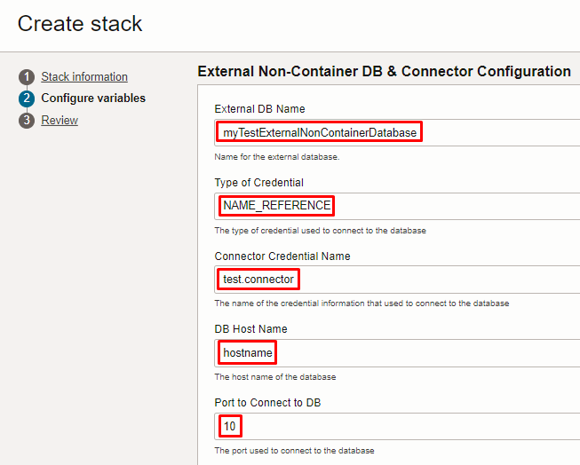
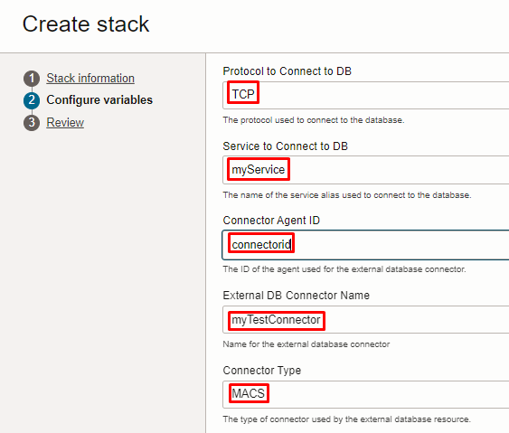
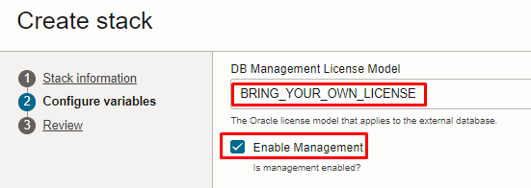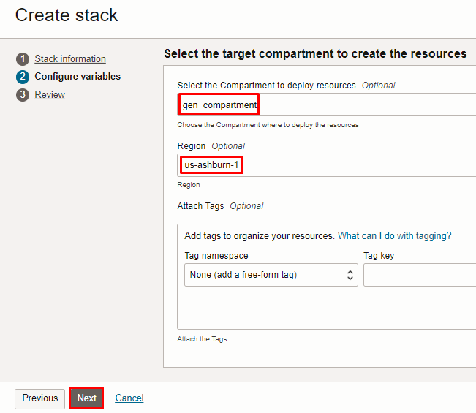

Note: select the right compartment to apply the stack in the OCI

Click “NEXT” Click “CREATE”

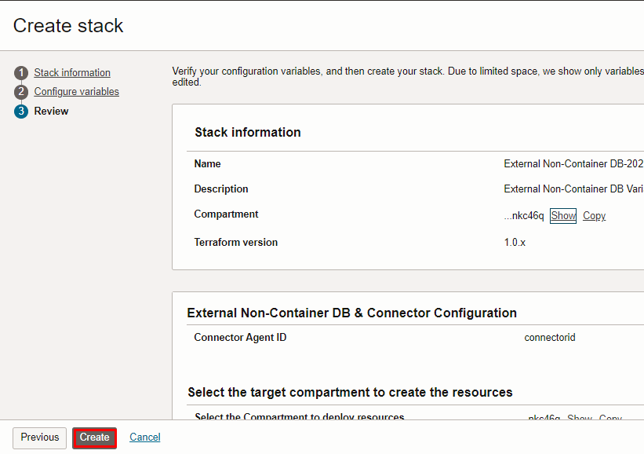

Plan the Job

Click the “Plan”

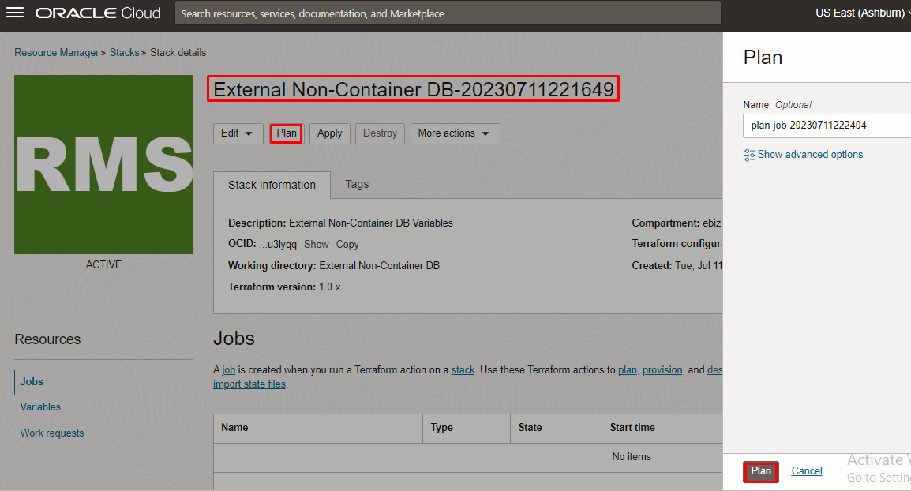

Verify the Plan is successful.

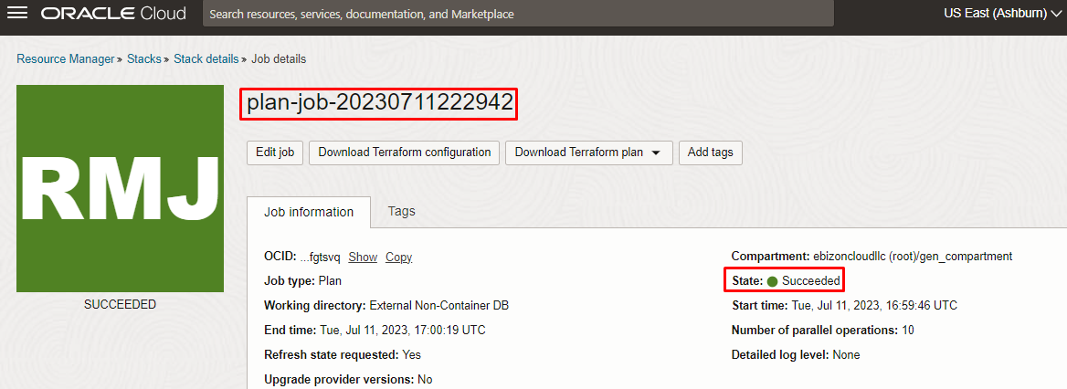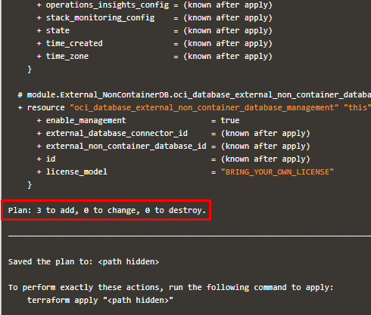

# END #

